**DAILY ONLINE ACTIVITIES SUMMARY**

|  |  |  |  |  |  |
| --- | --- | --- | --- | --- | --- |
| **Date:** | | **27/06/2020** | **Name:** | **JASLINE SHARON TAURO** | |
| **Sem & Sec** | | **4th sem, A Section** | **USN:** | **4AL18CS029** | |
| **Online Test Summary** | | | | | |
| **Subject** | **DATA COMMUNICATION** | | | | |
| **Max. Marks** | **30** | | **Score** | **25** | |
| **Certification Course Summary** | | | | | |
| **Course** | | DevOps ENGINEER | | | |
| **Certificate Provider** | | **AWS Educate** | **Duration** | | **4 hrs.** |
| **Coding Challenges** | | | | | |
| **Problem Statement:**  Write a C program to print kth digit. | | | | | |
| **Status: EXECUTED** | | | | | |
| **Uploaded the report in GitHub** | | | **YES** | | |
| **If yes Repository name** | | | <https://github.com/jaslinesharontauro/C_Prgms> | | |
| **Uploaded the report in slack** | | | **YES** | | |

Online Test Details: (Attach the snapshot and briefly write the report for the same)

Certification Course Details: (Attach the snapshot and briefly write the report for the same)

Coding Challenges Details: (Attach the snapshot and briefly write the report for the same)

ONLINE TEST DETAILS:

Today the assessment was conducted on the subject “DATA COMMUNICATION”. The test was based on the Fifth module of this subject. There were total 30 number of MCQ type questions of one mark each, out of which I scored 25.

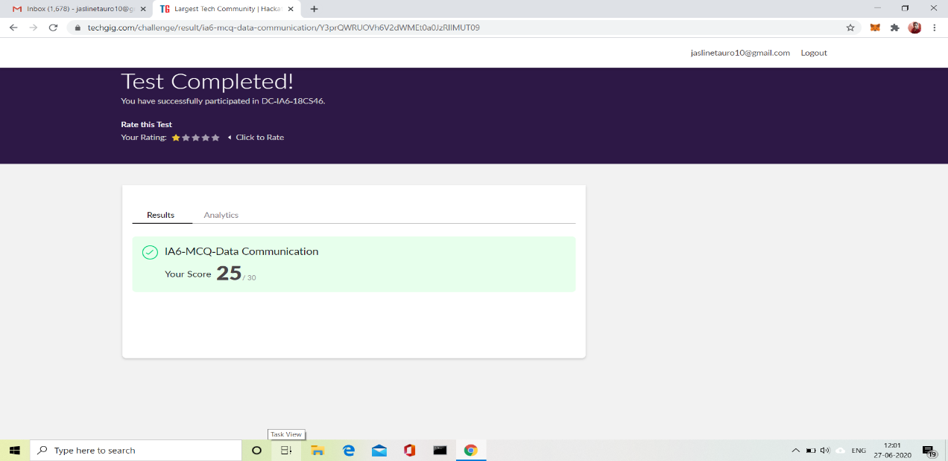

CERTIFICATION COURSE DETAILS:

## Today I have continued the course “DevOps Engineer” by AWS Educate. In this course today I learnt about ‘Networking-Architecture, Troubleshooting, Provisioning and Directory Service’. Today I have completed module of this course, And I have also completed the assessment of this module.

## 





WEBINAR DETAILS:

Today I have attended the webinar on “Loops, Conditional Statements, Array” by Assistant Professor Ms. Megha D. hedge, CSE department- AIET. The session was very interesting. There was a Quiz conducted based on the webinar. The Quiz was of MCQ type.

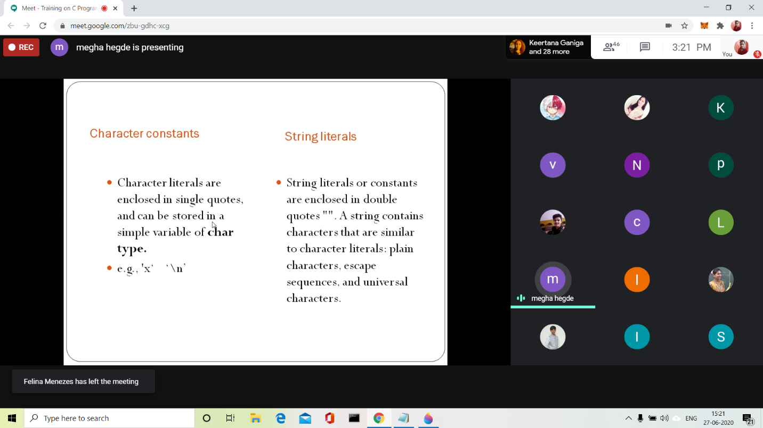

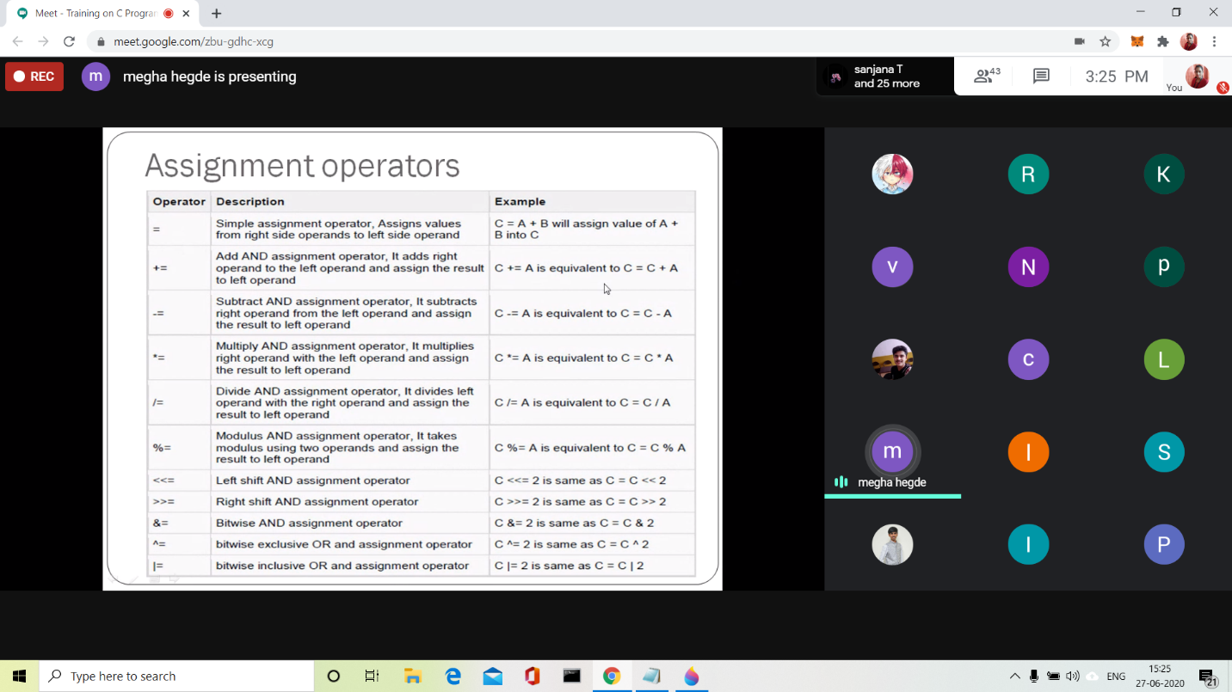

CODING CHALLENGES:

Problem Statement:

Write a C program to print kth digit.

Given two numbers a and b, find kth digit from right of a^b.

Input:

The first line of the input contains T denoting the number of test cases. Each of the next T lines contains three space separated positive integers denoting the value of a, b and k respectively.

Output:

For each test case, output the kth digit from right of a^b in new line.

Constraints:

1<=T<=100  
1<=a , b <=15  
1<=k<=|total digits in a^b|

Example:

Input:  
2  
3 3 1  
5 2 2

Output:  
7  
2

Hint  
Output: 1  
Explanation 3^3 = 27 for k = 1. First digit is 7 in 27  
Output: 2  
Explanation 5^2 = 25 for k = 2. First digit is 2 in 25

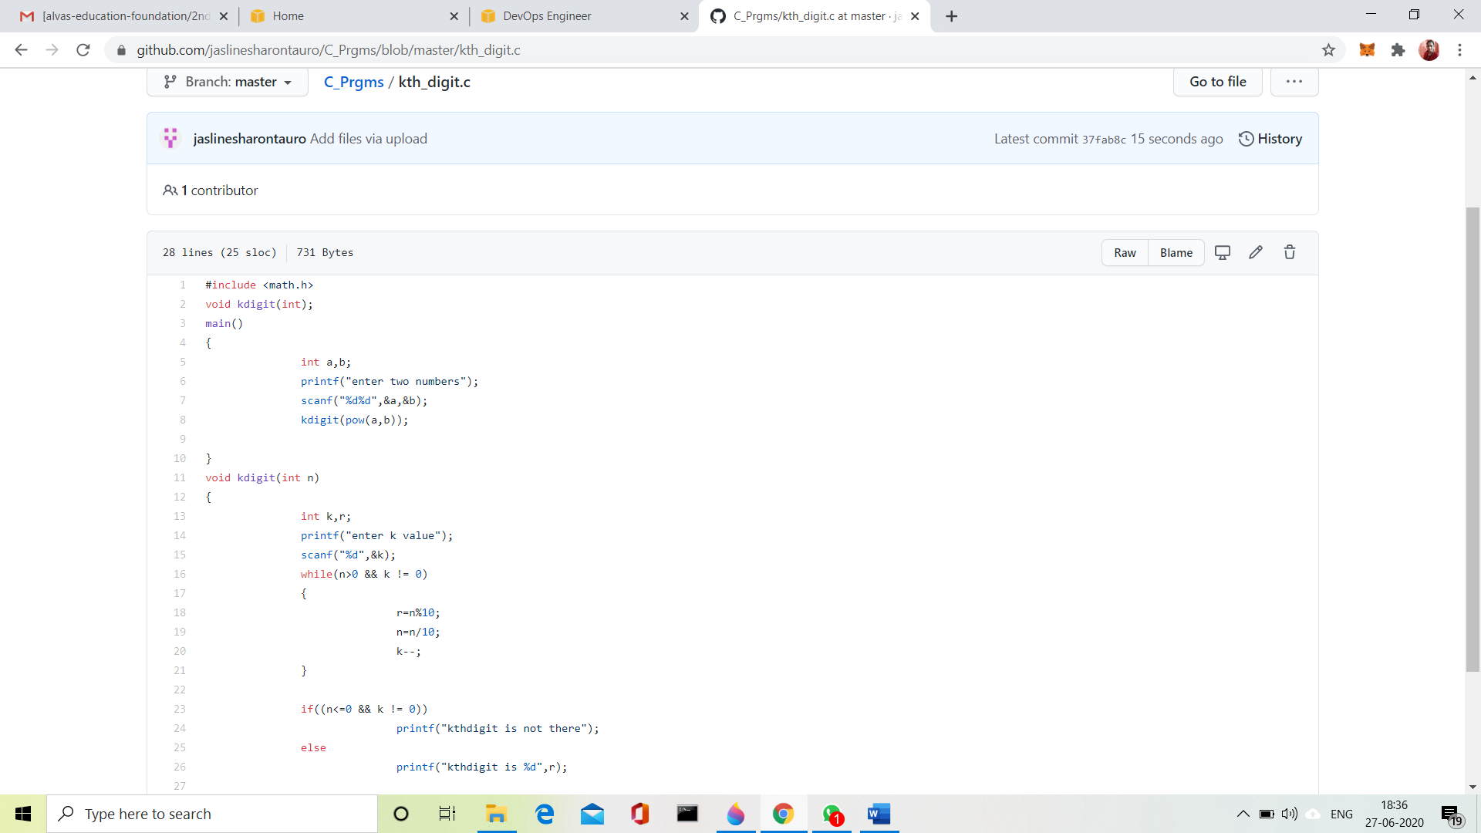

Solution Uploaded in GitHub.